Table of Contents
Time & Attendance Roles 3
Time Reporter Types 4
Positive Time Reporter Guidelines 4
Exception Time Reporter Guidelines 5
Work Schedules 6
General Information 6
Types of Work Schedules 6
Assigning a Work Schedule to an Employee 7
Updating an Employee’s Assigned Work Schedule 12
Navigating to the Timesheet 13
Navigating to an Employee’s Timesheet (Timekeeper, TA Admin, Supervisor) 13
Navigating to the Timesheet as an ESS User (Employee) 15
Timesheet Overview 16
Timesheet Header 17
Select Another Timesheet Section 18
Timesheet Grid 19
Timesheet Tabs 22
Time Reporting Codes 32
Time Entry 34
Positive Time Reporter 34
Exception Time Reporter 38
Sample Pay Calendars 41
Sample Hourly Pay Calendar 41
Sample Salaried Pay Calendar 42
Time Administration Process 43
Time Exceptions 44
General Information 44
Time Exception Examples 44
Absence Events 45
General Information 45
Creating an Absence Event 45
Reforecasting a Future Absence Event 52
Reforecasting Example 52
Updating an Absence Event 53
Time and Absence Approval 54
Agency Configuration (Use of Cardinal) 54
Approving Time and Absences 55

Time & Attendance Roles
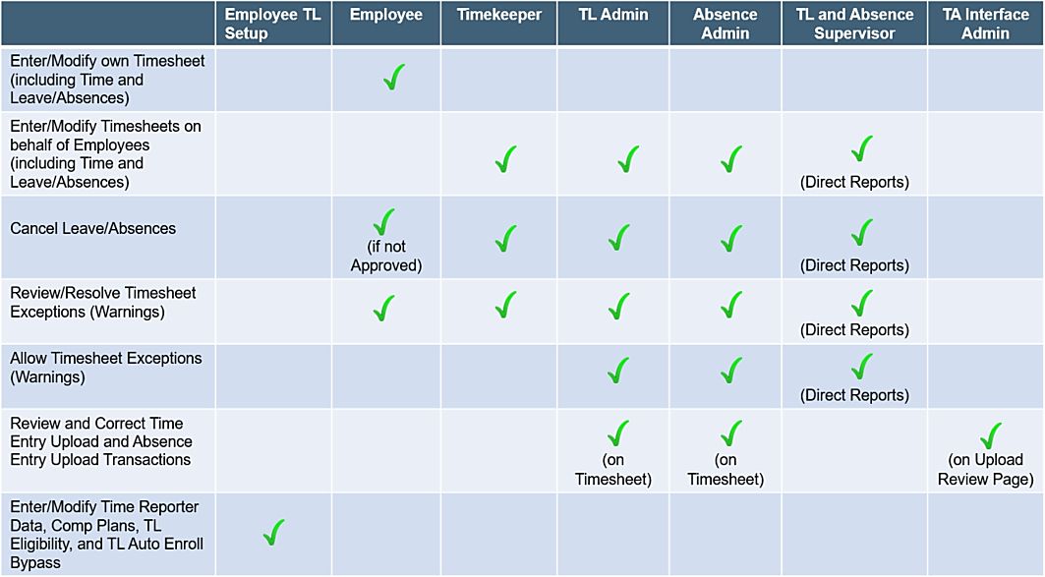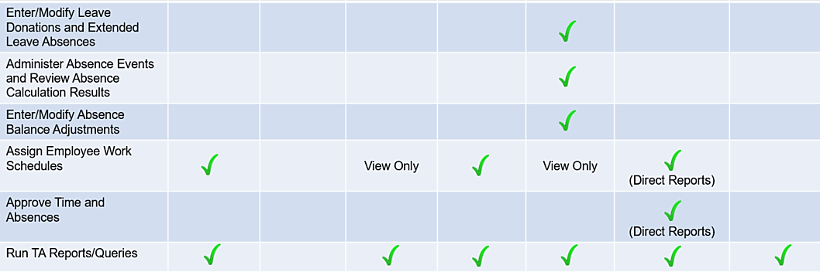

Time Reporter Types

Positive Time Reporter Guidelines

Entering Hours:
- All hours worked must be entered on the Timesheet
- Report the actual hours worked on the day they were worked (no lump sum reporting)
- Comp and overtime leave are reported in the Timesheet grid when earned and taken

Hourly Employees:
- Hourly employees are always set up as Positive Time Reporters and they must enter and submit all
hours on the Timesheet
- Once approved, the Timesheet is then sent to payroll for processing and payment

Salaried Employees:
- Salaried employees with a Variable Work Schedule are always setup as Positive Time Reporters
- and they must enter and submit all hours on the Timesheet
- Once approved, the Timesheet is then sent to payroll for processing and payment

Entering Overtime:
- Enter overtime on the Timesheet on the day(s) that it occurred (no lump sum reporting)

Timesheet Submission:
- All productive and non-productive time must be reported
- Hourly employees must submit time in order for it to be processed by payroll
- Salaried employees must submit time for overtime and shift payments to be processed and paid,
- for the accounting distributions to be accurate, and for the absence balances to be updated in a timely manner
- The Timesheet must be submitted at a minimum once per pay period

Exception Time Reporter Guidelines

Work Schedule:
- Cardinal generates the employee’s hours based on their Work Schedule

Exceptions to the Work Schedule:
- Must be entered on the day(s) it occurred
- If any exception is entered on a day, all time must be entered for that day

Exception Examples:
- Employee worked a different day or worked hours that differ from their Work Schedule
- Employee worked overtime
- Employee reports an Absence
- Employee worked their regular Work Schedule, but needs to enter ChartField details

Timesheet Submission:
- If any exceptions/time were entered on the Timesheet, the Timesheet must be submitted (at a
minimum once per pay period)
- If no exceptions were entered, Cardinal will generate the hours based on the employee’s Work Schedule and the Timesheet does not need to be submitted

Work Schedules

General Information

Work Schedules define when and how productive and non-productive time are reported on the Timesheet. For exception time reporters, Work Schedules are also used to generate payable time.

Each employee must have an assigned Work Schedule in Cardinal.

Note: Work Schedules are effective dated and required for Timesheet rule processing and for absence duration calculations for Agencies utilizing Cardinal as their Leave/Absence system of record.
Users with the following roles have the ability to assign/update an employee’s Work Schedule:

Users with the following roles have the ability to assign Work Schedules to an employee and update the Work Schedule currently assigned to an employee:
- Time & Labor (TL) Administrator
- TL Employee Setup Administrator
- The employee’s manager/supervisor (TL Supervisor)

Types of Work Schedules

- Hourly Work Schedule – This is a Work Schedule with zero pre-defined hours and should only be assigned to hourly (wage) employees. All hourly employees must report all hours worked on their Cardinal Timesheet in order to be paid

- Set Work Schedule – This is a non-flexible Work Schedule with predictable days and hours and should only be assigned to salaried employees. A set Work Schedule could also include a rotating day pattern

- Variable Work Schedule – This is a flexible Work Schedule that is set up in the system as 24 hours a day 7 days a week and should only be assigned to salaried employees. This type of Work Schedule requires employees to report all hours on their Cardinal Timesheet

Assigning a Work Schedule to an Employee
- To assign a Work Schedule to an employee, access the Assign Work Schedule page using the following path:
Navigator > Manager Self Service > Time Management > Manage Schedules > Assign Work Schedule
The Assign Work Schedule Search page displays.
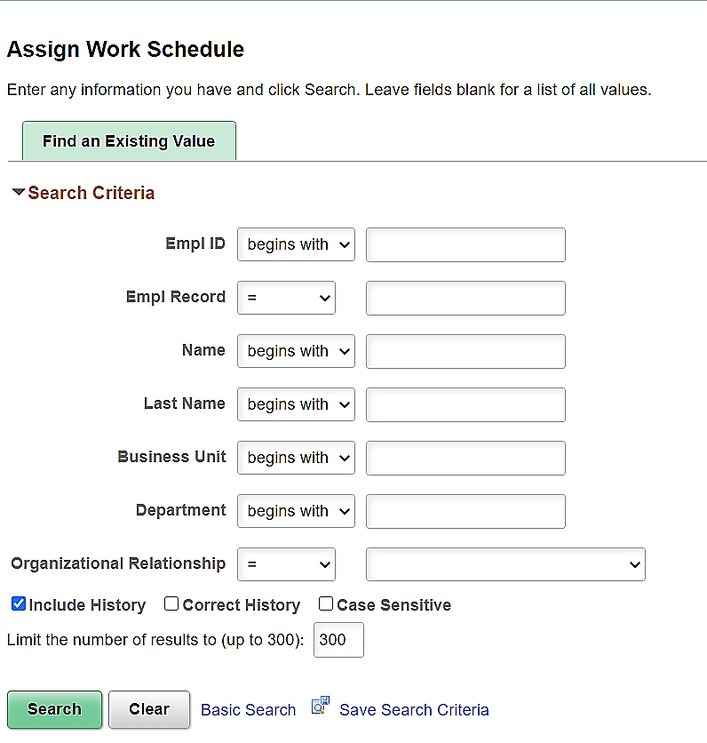
- Enter the applicable Employee ID in the Empl ID field.
- Click the Search button.

The Assign Work Schedule page displays with the Primary Schedule tab displayed by default.
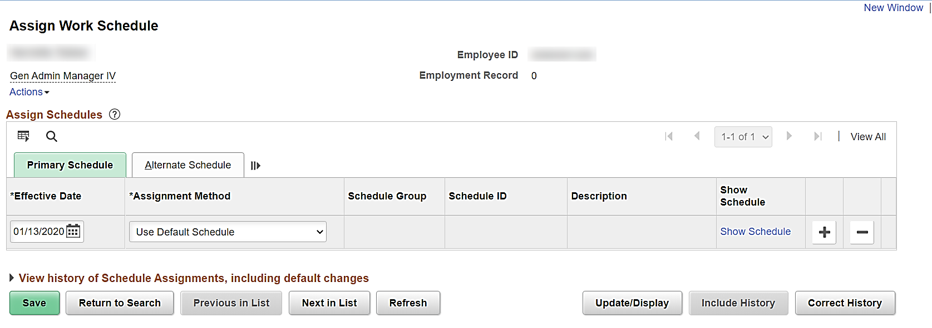
- The Effective Date field defaults to the current system date. Update this date using the Effective Date Calendar icon as needed.
- The Assignment Method field defaults to “Use Default Schedule”. Change this to “Select Predefined Schedule” using the dropdown button.
The Assign Work Schedule page refreshes.
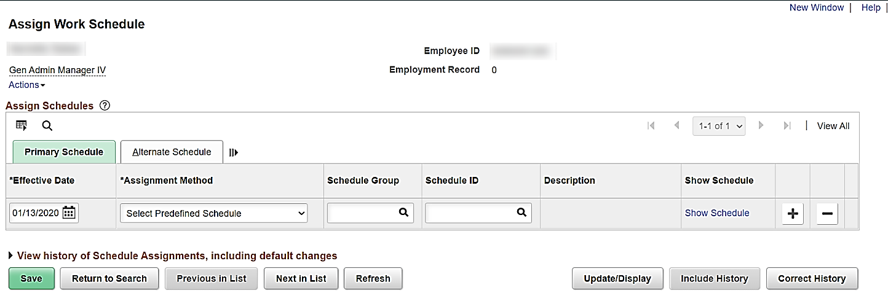

- Select the applicable Schedule Group using the Schedule Group field Look Up icon. The Schedule Group determines which schedule options (Schedule IDs) are available for selection. There are two types of Schedule Groups available which are listed below:
- STATE Schedule Group – the schedule options (Schedule IDs) available for selection are used across all state agencies. Select this option unless there is a schedule that is unique for your agency
- All other Agency Specific (Business Unit) Schedule Groups – the schedule options (Schedule IDs) available for selection include weekly schedules that are uniquely configured for the agency (business unit). The use of a Variable schedule (24 hours/7 days) is only found under the agency specific Schedule Groups
- Select the applicable Schedule ID using the Schedule ID field Look Up icon. Select the Work Schedule that is appropriate for the employee.
Note: Schedule IDs are smart coded, start with the applicable number of hours, and incorporate the on/off pattern of work days for a two-week pay period.
The Assign Work Schedule page refreshes.
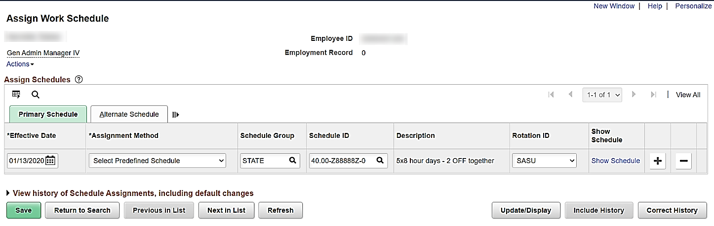
- The Description and Rotation ID fields default based on the Schedule ID selected. The Rotation ID denotes either:
  - The relative day(s) in the schedule pattern where the employee will be off. In this example, the Rotation ID of “SASU” indicates that the 2 days off together each week are Saturday and Sunday
OR
- When a schedule can vary from one week to the next week, you must select which of those weeks needs to be the start week. The correct Rotation ID needs to be selected based on the employee’s first day in the weekly pattern and that is the effective date for the start of that schedule
Note: The Rotation IDs available for selection will vary based on the Schedule ID.
- Click the Show Schedule link to view a visual representation of the schedule and confirm that the correct schedule was selected.
The Schedule Calendar page displays in a pop-up window.
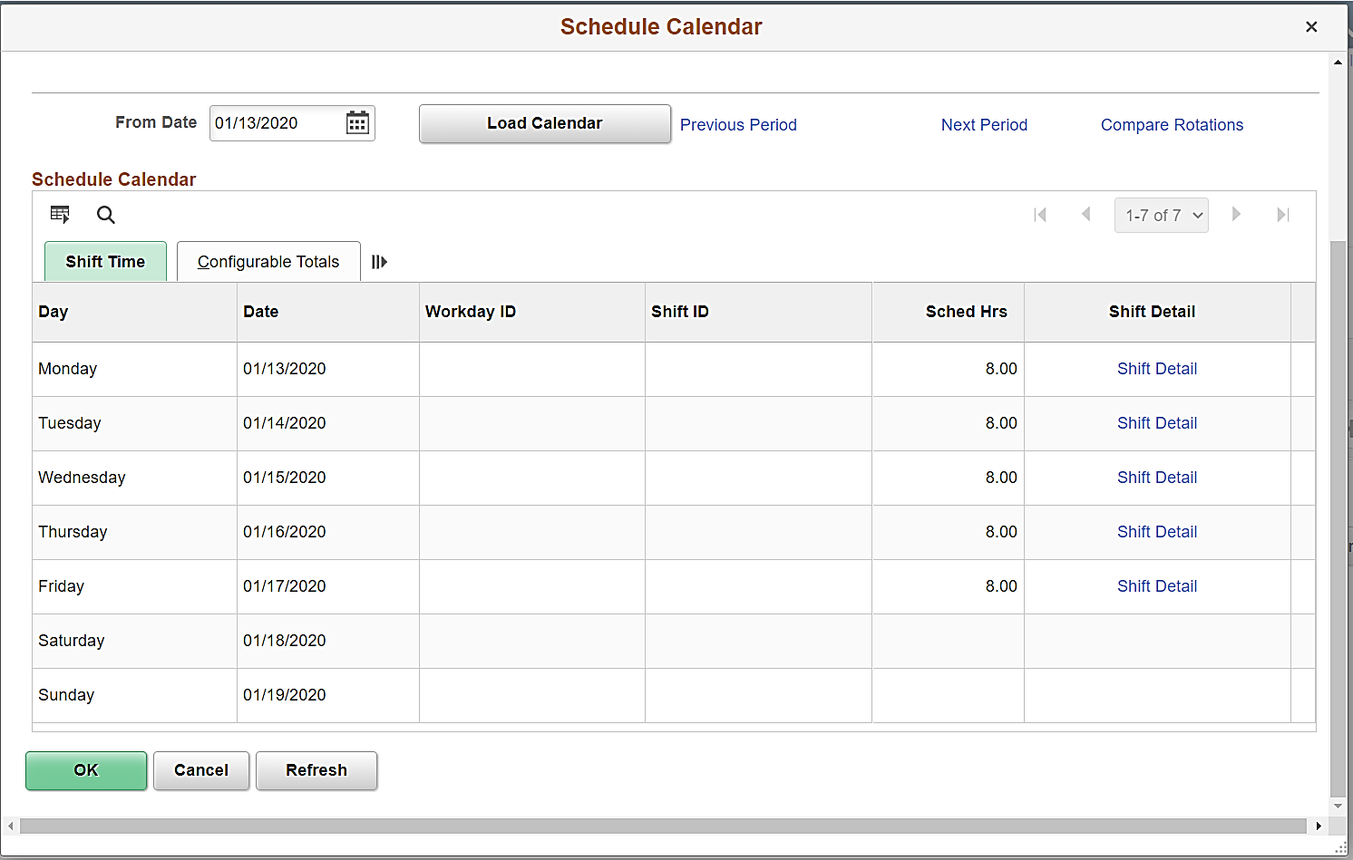
- Review the schedule information. Once confirmed as correct, click the OK button.

The Assign Work Schedule page returns.
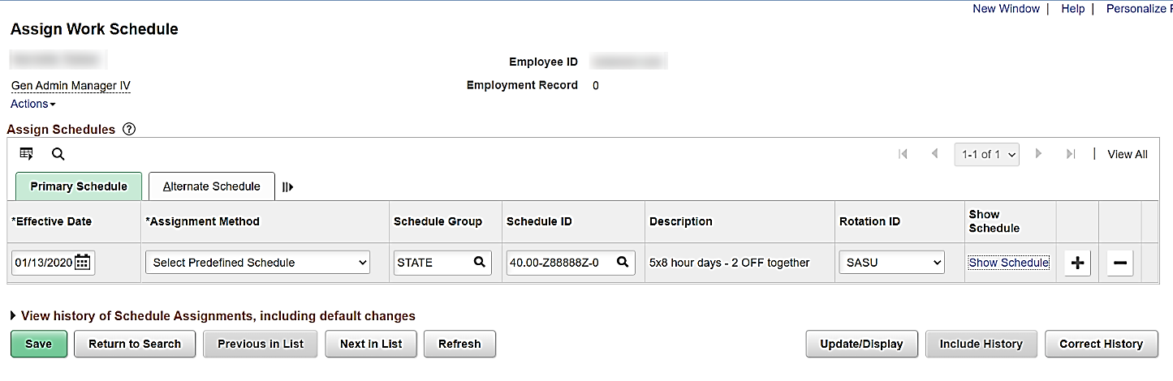
- Click the Save button.

Updating an Employee’s Assigned Work Schedule
- To update the assigned Work Schedule for an employee, access the Assign Work Schedule page in the same way covered in the “Assigning a Work Schedule to an Employee” section (Steps 1 – 3).
The Assign Work Schedule page displays with the Primary Schedule tab displayed by default.
- Click the Add a New Row icon.
The Assign Work Schedule page refreshes and a new row displays.
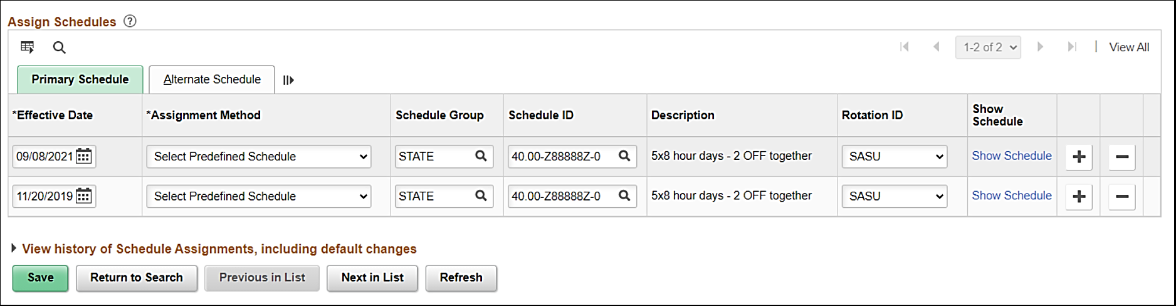
- The Effective Date field defaults to the current system date. Update this date using the Effective Date Calendar icon. This is the date that the new Work Schedule will take effect for the Employee.
- Assign the new Work Schedule to the employee in the same way covered in the “Assigning a Work Schedule to an Employee” section (Steps 5 - 11).

Navigating to the Timesheet

Navigating to an Employee’s Timesheet (Timekeeper, TA Admin, Supervisor)
- Navigate to the Timesheet page using the following path:
Team Time Tile > Timesheet
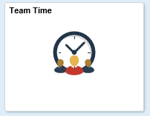
The Timesheet Summary page displays.
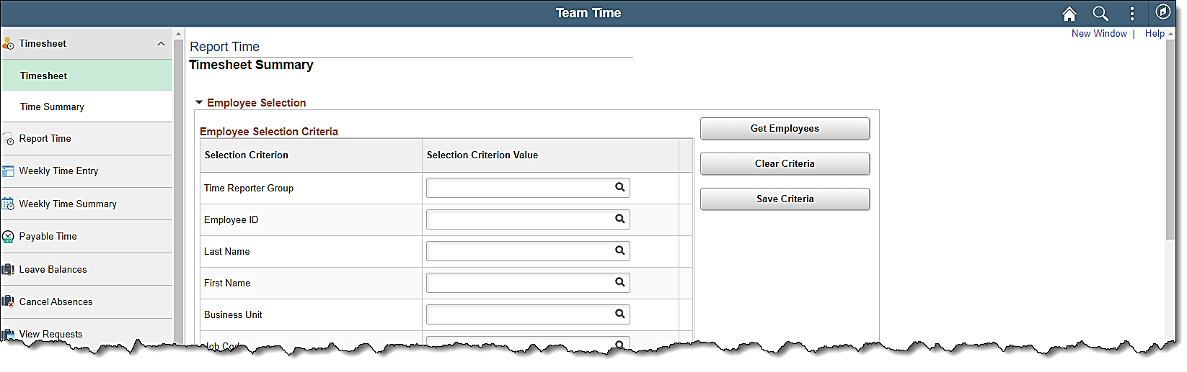
- Enter the applicable Employee ID or known portion of the Employee ID in the Employee ID field.
- Click the Get Employees button.
The Search Results display on the bottom portion of the Timesheet Summary page.
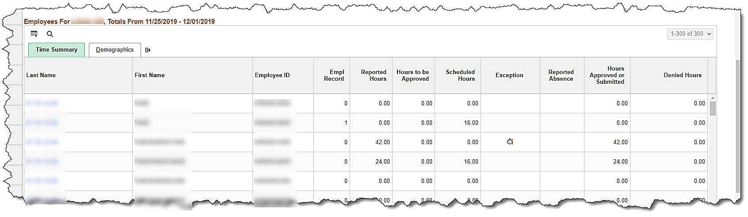
- Click on the Last Name link for the applicable employee.

The Timesheet page displays for the applicable employee.
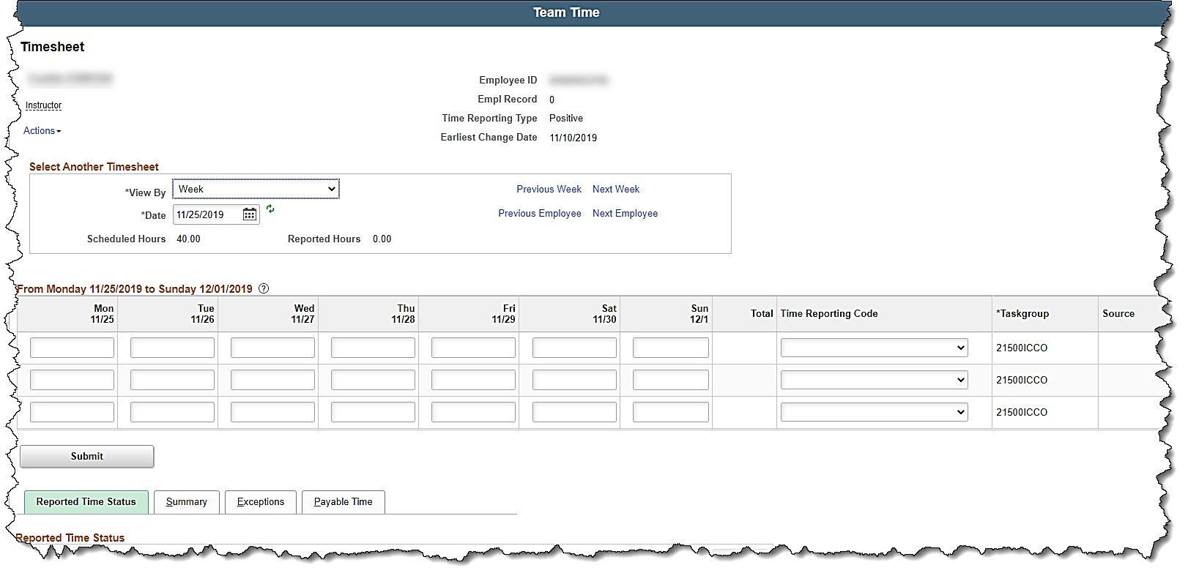

Navigating to the Timesheet as an ESS User (Employee)
- Click the Time tile on the Cardinal Homepage to navigate to the Timesheet page.
The Timesheet page displays.
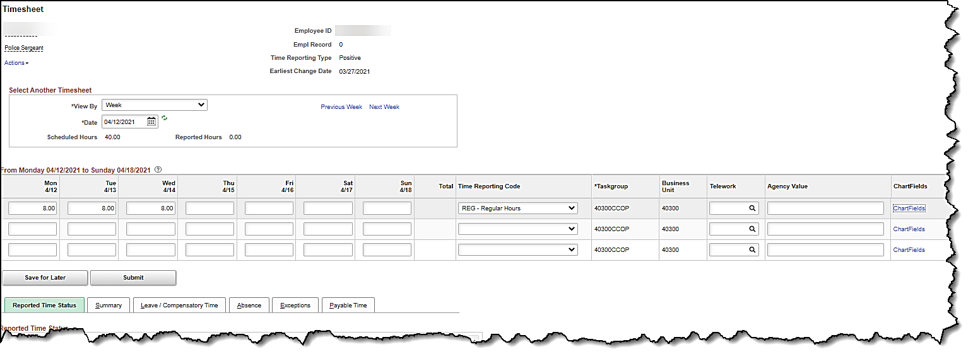
Note: If the correct week is not displayed, use the Previous Week link, Next Week link, or Date field to navigate to the correct week.

Timesheet Overview

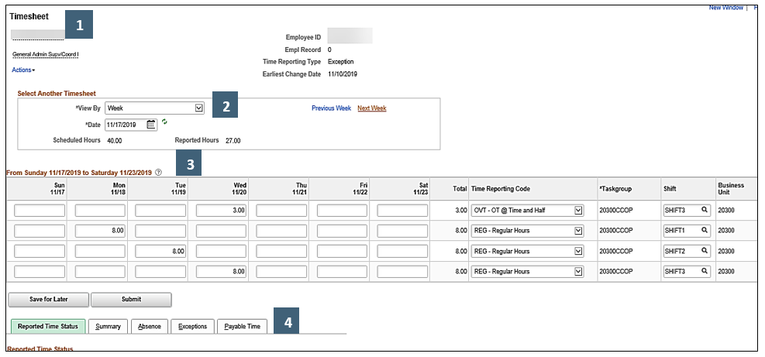

Timesheet Header
1

Timesheet Header Section
Fields/Data | Description
Employee Name | Employee’s first and last name (hover over title for additional information)
Employee ID | Employee ID Number
Job Title | Employee’s job title (hover over title for additional information)
Employee Record | An auto-assigned number to uniquely identify an employment instance for an employee. This is used within Cardinal to associate different Jobs to an employee (i.e., record 0, 1, 2, etc.).
Time Reporting Type | Positive or Exception
Earliest Change Date | This field is used by the Time & Labor Administrators to determine the earliest addition or update to time related date for the employee
Actions | Not utilized in Cardinal

Select Another Timesheet Section
2

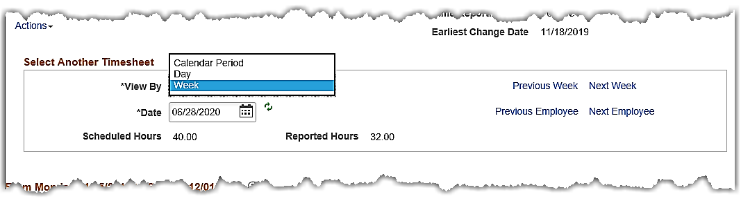

Select Another Timesheet Section
Fields/Data | Description
View By | Controls the Timesheet view. The default view of the Timesheet is a weekly format
Calendar Period | This view is based on the Pay Calendar (e.g., Salaried 10th-24th or 25th-9th, Faculty 1st-15thor 16th—End of the Month, Hourly biweekly)
Day | View one day based on the selection
Week | View a one week time period based on the selection
Date | Enter a specific date, date in a week, etc. to be shown on the Timesheet. . Click on the Calendar icon to open a Calendar page and then select the applicable month, year, and day. The week that includes the selected date displays. The start day always defaults to Monday, but can be changed if the scheduled start day is different.
Refresh Timesheet Icon | Use this icon to refresh the Timesheet when changes are made to the View By and Date Fields
Scheduled Hours | Displays the total number of hours the employee is scheduled to work for the date(s) selected
Reported Hours | Displays the total number of hours the employee reported for the date (s) selected
Previous Week | Click this link to view the previous week
Next Week | Click this link to view the next week
Previous Employee | Click this link to view the previous employee in the list (search results on Timesheet Summary page)
Next Employee | Click this link to view the next employee in the list (search results on Timesheet Summary page)

Timesheet Grid
3

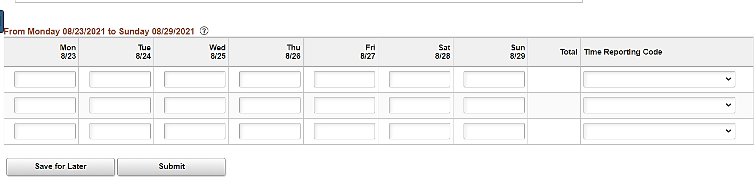

Timesheet Grid Section
Fields/Data | Description
From Monday xx/xx/xxxx to Sunday xx/xx/xxxx | This section is used to enter hours by day and by Time Reporting Code (TRC). This view will vary based on the selections made in the View By section
Time Reporting Code (TRC) | This dropdown contains codes used to classify the time being reported. The codes will vary based on agency configuration, employee type (e.g., hourly, salaried), the workgroup to which the employee is assigned, and their eligibility (e.g., overtime, compensatory time).

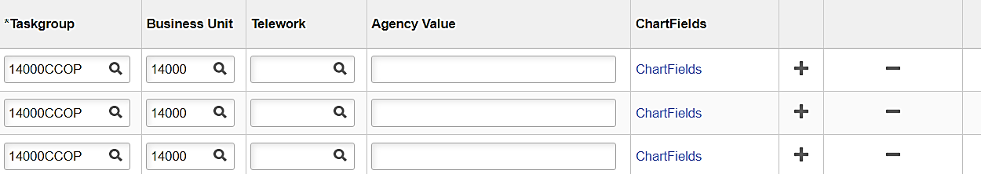
Timesheet Grid Section (continued)
Fields/Data | Description
Taskgroup | Coding string representing a group of time reporters with similar time and task reporting requirements. This drives the billing defaults for the time reporter to the Department, Cost Center, Chart of Account/SpeedTypes, or Project. The Taskgroup string begins with the agency Business Unit. This field should not be changed
Business Unit | The agency's business unit/company. This field should not be changed
Telework | (if applicable) Field used to identify time that was approved for telework. The only valid value is “TELE”
Agency Value | Free form field used to collect agency specific information
Add a New Row and Remove a Row icons | The Timesheet grid defaults with three rows for time entry. The Add a New Row icon (+) and Remove a Row (-) icon allow the employee or Timekeeper to add or delete rows as needed
Shift | Employees who are eligible for shift differential will have the Shift field on their timesheet. If a shift differential is not specified, it will default to shift 1.
ChartFields | (if applicable) Hyperlink that is available for entry/selection of ChartFields for all time entered. An agency can elect to have ChartFields setup one of the following ways for each employee
Default | the ChartField link is not visible on the Timesheet because the funding information will always use the position or department defaults
Optional | the ChartField link is visible on the Timesheet because they have the option of overriding the default values as needed
Required | the ChartField link is visible on the Timesheet and ChartFields must be entered on the Timesheet for all productive time

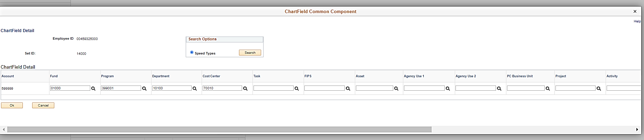

ChartField Common Component Page
Fields/Data | Description
**Speed Types | Speed Types are configured by PPS and when used, they will auto-populate the ChartFields segments based on pre-defined criteria. Not all agencies have elected to use Speed Types
ChartField Detail Segments | These fields can be entered manually or auto-populated by using a Speed Type

Timesheet Tabs
4

Reported Time Status Tab:
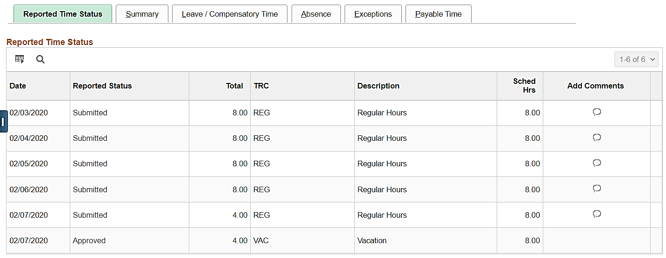

Reported Time Status Tab
Fields/Data | Description
Date | Date of entry
Reported Status | Displays the current status. See the next section for a full list of statuses.
Total | Total number of hours reported for this date entry
TRC | Time Reporting Code associated with the hours reported
Description | Description of the Time Reporting Code
Scheduled Hours | Total number of scheduled hours for this date
Add Comments | The Add/Review Comments icon is available for productive and non-productive time from the Timesheet. This icon is not available for absences.

Below are charts showing the Reported Time Status descriptions and actions available based on grace periods and roles.
Reported Time Status Descriptions
Status Type | Status | Code | Next Status | Description | Agency Type
Reported Time | Saved | SV | SB | Time that has been entered, but not submitted for processing | Online
Reported Time | Saved | SV | NA | Absence that has been entered, but not submitted for approval | AM
Reported Time | Saved | SV | NA | Time for interfacing employee that has been saved online but not submitted for approval | Interfacing
Reported Time | Submitted | SB |  | Time that has been reported and submitted for processing | Online
Reported Time | Needs Approval | NA | AP | Absence that has been submitted and is pending approval | AM
Reported Time | Needs Approval | NA | AP, CL | Time for interfacing employee that has been submitted online and is pending approval | Interfacing
Reported Time | Approved | AP |  | Absence that has been approved | AM
Reported Time | Approved | AP |  | Time for interfacing employee that has been interfaced as approved or submitted and approved online | Interfacing
Reported Time | Closed | CL |  | Time closed by the TA Expired Grace Approver | Online + Interfacing

* Agencies using Cardinal online for TA will only see a status of either Saved or Submitted for time entered on the Timesheet Grid.
**Agencies using Cardinal Absence Management only will see Needs Approval or Approved for absences. Interfacing Agencies will generally only see Approved when the time is successfully interfaced into Cardinal.

Reported Time Status actions available based on grace periods and roles.
Status Type | Code | Agency Type | <90 days | >90 <365 | >365
Reported Time | SV | Online | *Employee/Supervisor/Timekeeper/TL Admin Submit or Delete | *TL Admin Submit or Delete  *TA Expired Grace Approver Close or Delete | *TA Expired Grace Approver Close or Delete
Reported Time | SV | AM | *Employee/Supervisor/Timekeeper/TL Admin Submit or Cancel | *TL Admin Submit or Cancel  *AM Admin Approve or Void or Delete | *AM Admin Approve or Void or Delete (must request PPS to override 1 year retro limit for processing)
Reported Time | SV | Interfacing | *TL Admin Submit or Delete/Cancel | *TL Admin Submit or Delete/Cancel  *TA Expired Grace Approver Close or Delete | *TA Expired Grace Approver Close or Delete
Reported Time | SB | Online | No action needed | No action needed | No action needed
Reported Time | NA | AM | *Employee/Supervisor/Timekeeper/TL Admin Cancel  *Supervisor Approve | *TL Admin Cancel  *Supervisor Approve  *AM Admin Approve or Void or Delete | *AM Admin Approve or Void or Delete (must request PPS to override 1 year retro limit for processing)
Reported Time | NA | Interfacing | *Supervisor Approve  *TL Admin Delete | *Supervisor Approve (Must be done same day as Submit)  *TL Admin Delete  *TA Expired Grace Approver Close or Delete | *TA Expired Grace Approver Close or Delete
Reported Time | AP | AM | No action needed | No action needed | No action needed
Reported Time | AP | Interfacing | No action needed | No action needed | No action needed
Reported Time | CL | Online + Interfacing | No action needed | No action needed | No action needed

Summary Tab:
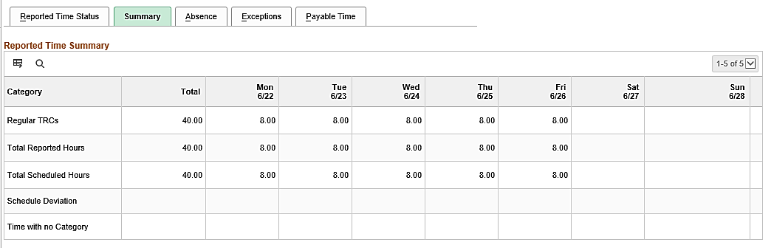

Summary Tab
Fields/Data | Description
Category | Reported time by category (this screenshot only displays what was submitted for this example, other TRCs could display here)
Regular TRCs | Hours reported using Regular Time Reporting Code
Total Reported Hours | The number of Regular Hours reported
Total Scheduled Hours | The number of Scheduled Hours
Scheduled Deviation | The number of reported hours greater or less than the employee’s Scheduled Hours
Time with no Category | Hours will not be displayed in this field as Cardinal prevents users from submitting hours without a Time Reporting Code
Total | Total number of hours reported for the week
Date | Hours reported by date

Leave/Compensatory Time Tab:
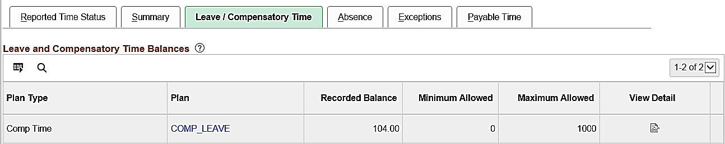

Leave/Compensatory Time Tab
Fields/Data | Description
Plan Type | Displays the Plan Type
Plan | Displays the Plan as either Comp or Leave Plan
Recorded Balance | Displays the employee’s current balance
Minimum Allowed | This is not the actual minimum number of hours allowed. This is a system defaulted value. The actual minimum hours allowed will be based on Agency policy.
Maximum Allowed | This is not the actual maximum number of hours allowed. This is a system defaulted value. The actual maximum hours allowed will be based on agency policy.
View Detail | Optionally, click this icon to view additional details including the expiration date

Absence Tab:
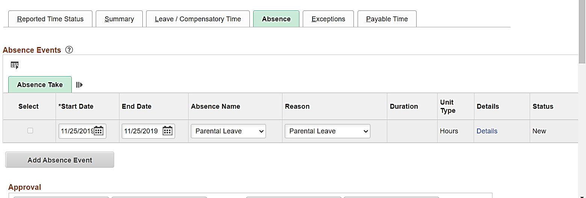
Absence Tab
Fields/Data | Description
Absence Take | Displays any absence event(s) that have been entered for the Timesheet dates
Add Absence Event | Click this button to add a new absence event

Exception Tab:
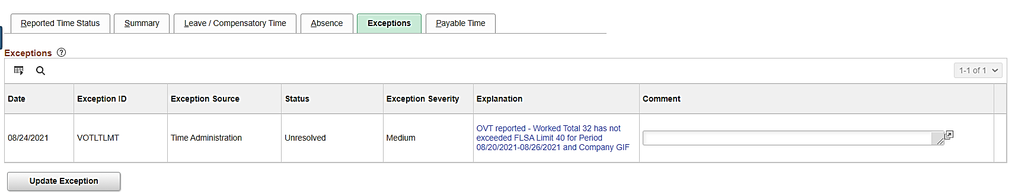

Exception Tab
Fields/Data | Description
Date | Date associated with the time that generated the exception
Exception ID | ID code used to identify Exceptions (For a detailed list of all exceptions, see the job aid titled TA Exceptions located on the Cardinal Website in Job Aids under Learning)
Exception Source | This field will always display as Time Administration
Status | Displays the current status of the exception. Please note that once resolved, the Exception will clear and no longer display here
Exception Severity | This field will display one of the following: Low, Medium, or High
Explanation | A brief description of the Exception. Click the link to view additional information
Comment | This field is optionally used to provide a comment pertaining to the exception

Payable Time Tab:
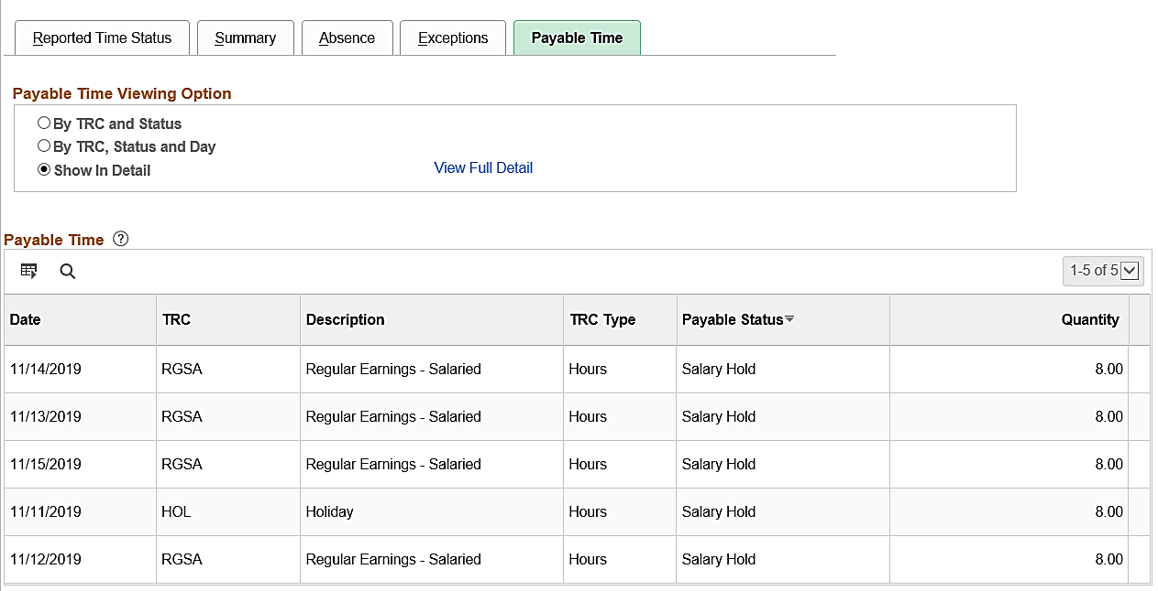
Payable Time Tab
Fields/Data | Description
View Full Detail | Optionally, click this link to view additional details about the payable time
Date | Date associated with the time
TRC | Time Reporting Code associated with the time
Description | Description of Time Reporting Code
TRC Type | Will always display as Hours
Payable Status | Displays the current status. See the next section for a complete list of statuses
Quantity | Number of hours entered

Below are charts showing the Payable Time Status descriptions and actions available based on grace periods and roles.
Payable Time Status Descriptions
Status Type | Status | Code | Next Status | Description | Agency Type
Payable Time | Needs Approval | NA | AP, VS, VH, CH, CL, NP | Time that has been processed by Time Administration and is pending approval | Online
Payable Time | Approved | AP | SP then TP | Time that has been approved and ready for payroll/distribution | Online
Payable Time | Estimated | ES | SP then TP | Time that does not require approval and is ready for payroll/distribution | Online + Interfacing
Payable Time | Overtime Hold | VH | AP | Time for salaried employees subject to overtime lag that has not yet been released for load to payroll | Online
Payable Time | Salary Hold | VS | PD | Time for salaried employees included in base pay pending distribution | Online
Payable Time | No Pay | NP |  | Time does not require pay or distribution | Online + Interfacing
Payable Time | Rejected by Payroll | RP | SP then TP or CL | Time rejected by load to payroll process | Online + Interfacing
Payable Time | Reversed | RV |  | Time reversed by payroll | Online + Interfacing
Payable Time | Sent to Payroll | SP | TP or RP | Time is in process of being loaded to payroll | Online + Interfacing
Payable Time | Taken by Payroll | TP | PD | Time loaded to payroll pending payroll processing | Online + Interfacing
Payable Time | Distributed | PD |  | Time paid and/or distributed to General Ledger | Online + Interfacing
Payable Time | Closed | CL |  | Time closed by distribution process, time rejected by payroll closed by TL Admin, or time closed by the TA Expired Grace Approver | Online + Interfacing

Payable Time Status actions available based on grace periods and roles.
Status Type | Code | Agency Type | <90 days | >90 <365 | >365
Payable Time | NA | Online | *Supervisor Approve | *TA Expired Grace Approver Approve  *TL Admin Delete Reported Time  *TA Expired Grace Approver Close or Delete | *TA Expired Grace Approver Close or Delete
Payable Time | AP | Online | No action needed | No action needed | No action needed
Payable Time | ES | Online + Interfacing | No action needed | No action needed | No action needed
Payable Time | VH | Online | No action needed | No action needed | No action needed
Payable Time | VS | Online | No action needed | No action needed | No action needed
Payable Time | NP | Online + Interfacing | No action needed | No action needed | No action needed
Payable Time | RP | Online + Interfacing | *Payroll Admin/TL Admin/SPO fix problem and reload time  *TL Admin Close | *Payroll Admin/TL Admin/SPO fix problem and reload time  *TL Admin Close | *Nightly job will Close
Payable Time | RV | Online + Interfacing | No action needed | No action needed | No action needed
Payable Time | SP | Online + Interfacing | No action needed | No action needed | No action needed
Payable Time | TP | Online + Interfacing | No action needed | No action needed | No action needed
Payable Time | PD | Online + Interfacing | No action needed | No action needed | No action needed
Payable Time | CL | Online + Interfacing | No action needed | No action needed | No action needed

Time Reporting Codes
Comp Time Plan | Time Reporting Codes (TRCs) Descriptions | TRC Selections on Timesheet
CARDINAL | Holiday, Holiday Pay Docking, Holiday Straight Extra, Office Closing | CLO, HNPM, HOLM, HOS
COMP_LEAVE | Comp Leave Earned, Compensatory Leave Taken, Comp Time Leave Payout, Comp Time Leave Adjust, Comp Time Leave Deduction, Comp Time Leave Adjust CNV, Holiday Straight Earned, for employees using Cardinal Absence Management | CALHE, CCA, CCD, CCL, CPO, ECHS, HCS, OCS, ONCHE
OT_LEAVE | Overtime Leave Earned, Overtime Leave Taken, Overtime Leave Payout, Overtime Leave Adjust, Overtime Leave Deduction, Overtime Leave Adjust CNV, for employees using Cardinal Absence Management | CALHE, ECT, OCA, OCD, OCL, OCT, OPO
PAID-OVS | OT @ Straight Time | OVS
PAID-OVT | OT @ Time and Half | OVT
PAID-EOS | Emerg OT @ Straight Time | EOS
PAID-EOT | Paid Emerg OT @ Time and Half | EOT
PAID-CALHP | Called Out Hours (Paid) | CALHP
PAID-ONCHP | On-Call Hours (Paid) | ONCHP
NONPROD_PD | Not required non-productive leave codes for employees using External Leave system | ADMR, ALIR, BMOR, CCLR, CLOR, CSLR, DLRR, DSKR, DSSR, ELPR, ELWR, EMSR, ERLR, FCSR, FSKR, FVCR, LTDR, MBLR, MILR, MIPR, MLDR, OCLR, PD1R, PD2R, PERR, PHER, PLLR, SCKR, SDPR, VACR, WRIR, ALIR, BMOR, CCLR, CLOR,CSLR, DLRR, DSKR, DSRR, ELPR, ELWR, EMSR, ERLR, FCSR FSKR, FVCR, LTDR, MBLR,MILR, MIPR, MLDR, OCLR, PD1R, PD2R, PERR, PHER, PLLR, SCKR, SDPR, WCIR
NONPROD_RQ | Required non-productive leave codes for employees using External Leave system | HCSR, HNPR, HOLR, HOSR, LNPR, STDR, STLR, WCLR, WCPR, WCSR
EARNOT-ONC | On-Call Hours (Earn) for employees using External Leave system | ONCHR
EARNAM-ONC | On-Call Hours (Earn) for employees using Cardinal Absence Management | ONCHE
EARNOT-CAL | Called Out Hours (Earn) for employees using External Leave system | CALHR
EARNAM-CAL | Called Out Hours (Earn) for employees using Cardinal Absence Management | CALHE
EARNOT-ECS | Emergency Comp Earn for employees using External Leave system | ECSR
EARNAM-ECS | Emergency Comp Earn for employees using Cardinal Absence Management | ECS
EARNOT-OCS | Comp Leave Earned for employees using External Leave system | OCSR
EARNOT-OCT | Overtime Leave Earned for employees using External Leave system | OCTR
EARNOT-ECT | Emergency OT Leave Earned for employees using External Leave system | ECTR
EARNAM-ECT | Emergency OT Leave Earned for employees using Cardinal Absence Management | ECT
AMNT–ONC$$ | On-Call Amount
AMNT-CAL$$ | Called Out Amount
AMNT-DIF$$ | Weekend/Holiday Diff Amount
AMNT-MED$$ | MedicationAmount

Time Entry

Positive Time Reporter

- Navigate to the employee’s Timesheet.
The Timesheet page displays.
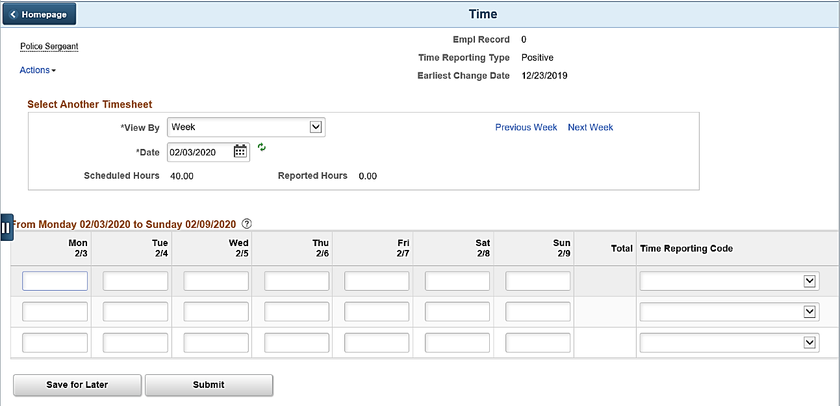

- Ensure that the correct Timesheet (dates) is displayed. Use the Date field, Previous Week link, or Next Week link within the Select Another Timesheet section as needed to navigate to the correct Timesheet.
- Use the first available row within the Timesheet Grid to enter the regular hours worked for each
applicable day.
- Select the applicable Time Reporting Code for the first row.
- Repeat Steps 3 and 4 to report any hours that need to be associated with a different Time Reporting Code or ChartField Distribution.
The following Steps (Steps 6 - 8) only need to be completed if ChartFields are required or if ChartFields are optional and any row of hours need to be charged against a ChartField distribution other than the default. If ChartField entry is not required, skip to Step 11.
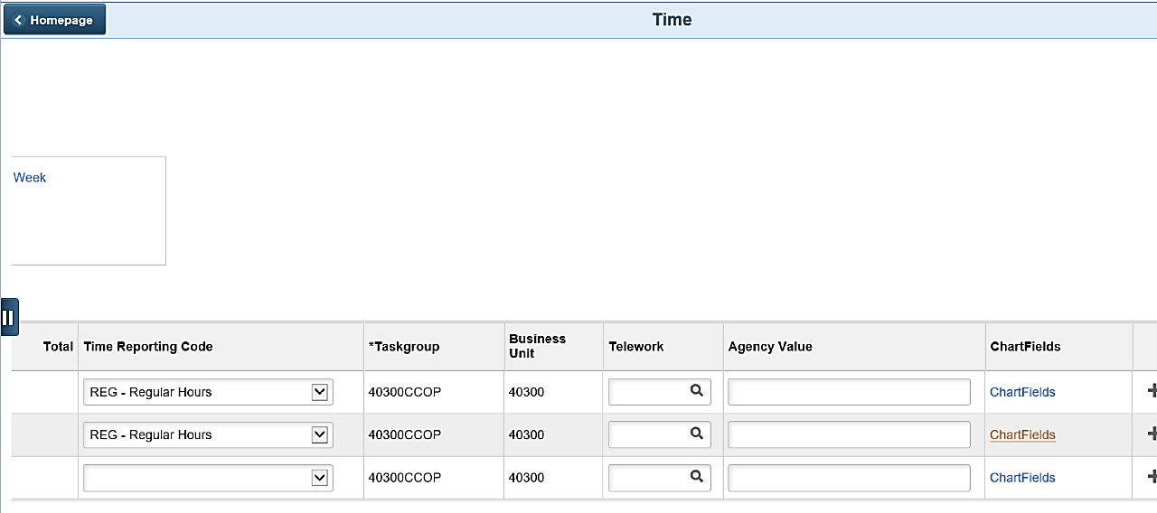
- Click the ChartFields link for the applicable row.
The ChartField Common Component page displays in a pop-up window.
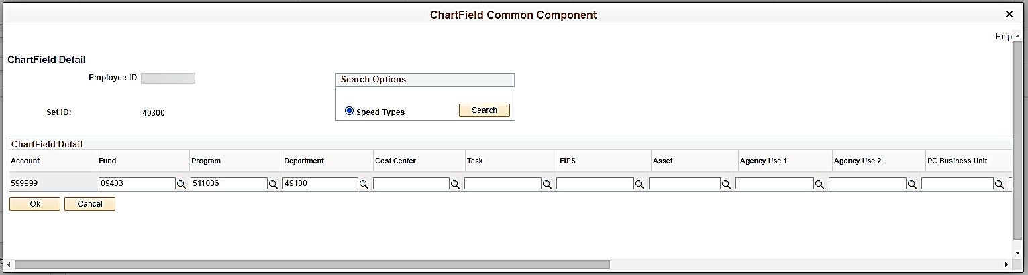

- Enter the applicable ChartField distribution segments.
Note: If the Agency is using Speed Types, optionally use the Speed Types functionality to define all or part of the ChartField distribution segments.
- Click the OK button.
The Timesheet page redisplays.
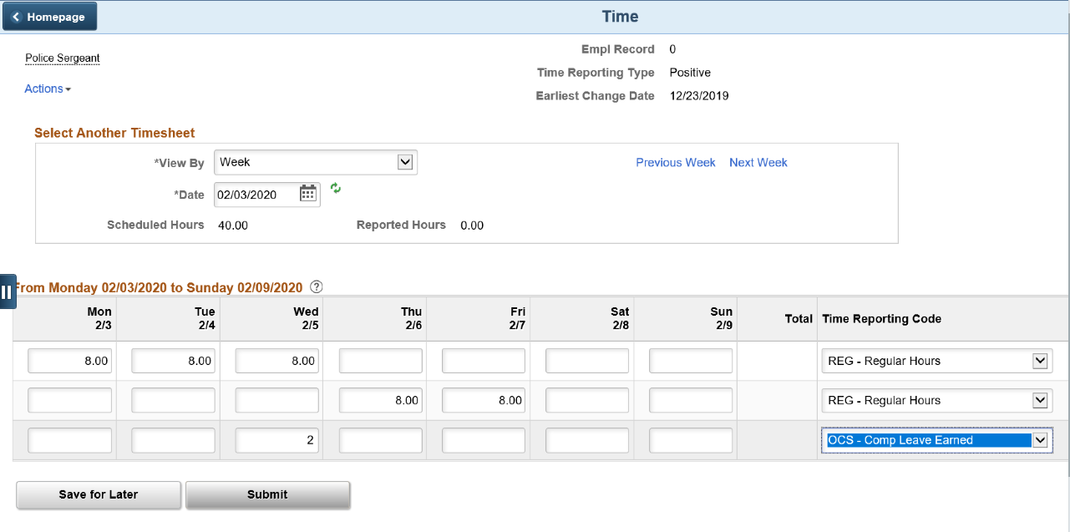
- Repeat Steps 6 – 8 if ChartField distribution information needs to be defined for any additional rows.
- Click the Submit button to submit the Timesheet for approval and processing.
The Submit Confirmation page displays.
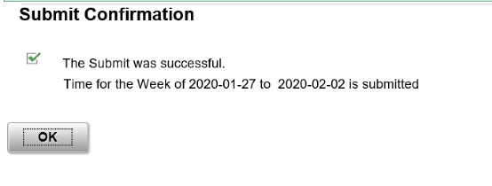
- Click the OK button.

Exception Time Reporter

- Navigate to the Timesheet.
The Timesheet page displays.
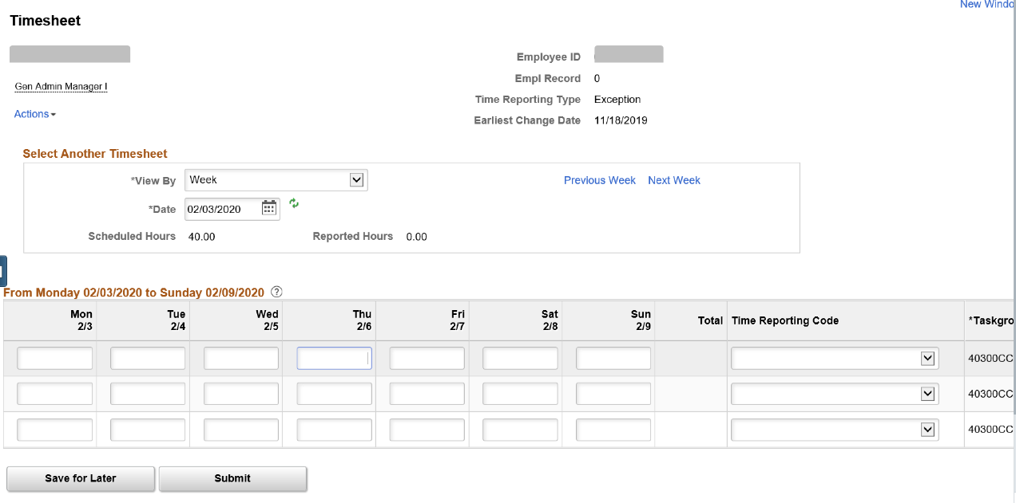
- Ensure that the correct Timesheet (dates) is displayed. Use the Date field, Previous Week link, or Next Week link within the Select Another Timesheet section as needed to navigate to the correct Timesheet.
- Use the first available row within the Timesheet Grid to enter any exception time that needs to be reported on the day(s) it occurred.
- Select the applicable Time Reporting Code for the first row.
- Enter the regularly scheduled hours for each day that any exception time was reported using the next available row.
- Select the applicable Time Reporting Code.
The following Steps (Steps 7 - 9) only need to be completed if ChartFields are required or if ChartFields are optional and any row of hours need to be charged against a ChartField distribution other than the default. If ChartField entry is not required, skip to Step 11.
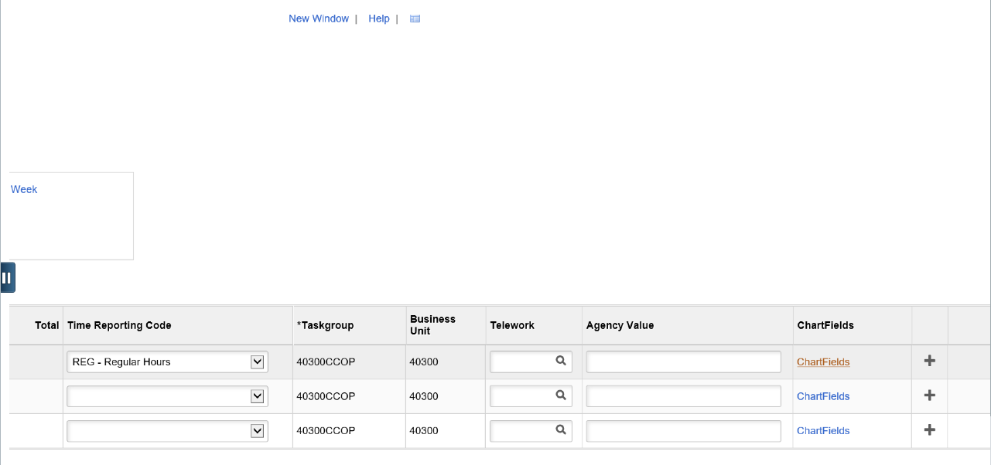
- Click the ChartFields link for the applicable row.
The ChartField Common Component page displays in a pop-up window.

- Enter the applicable ChartField distribution segments.
Note: If the Agency is using Speed Types, optionally use the Speed Types functionality to define all or part of the ChartField distribution segments.
- Click the OK button.
The Timesheet page redisplays.
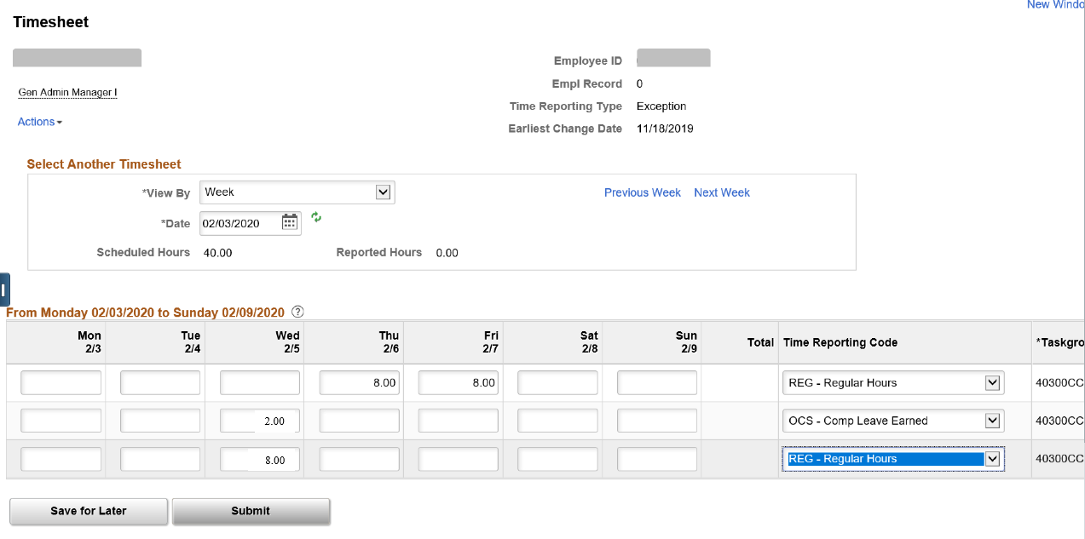
- Repeat Steps 7 – 9 if ChartField distribution information needs to be defined for any additional rows.
- Click the Submit button to submit the Timesheet for approval and processing.
The Submit Confirmation page displays.
- Click the OK button.

Sample Pay Calendars

Sample Hourly Pay Calendar

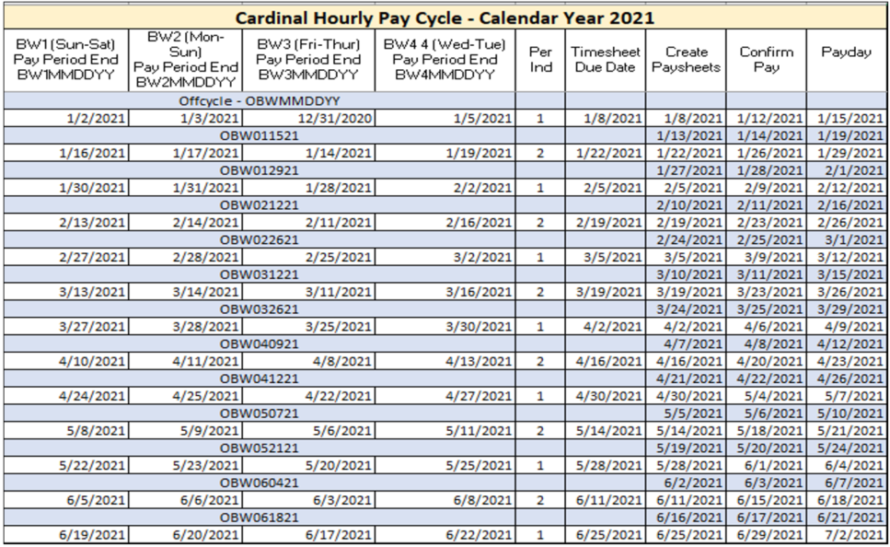

Sample Salaried Pay Calendar
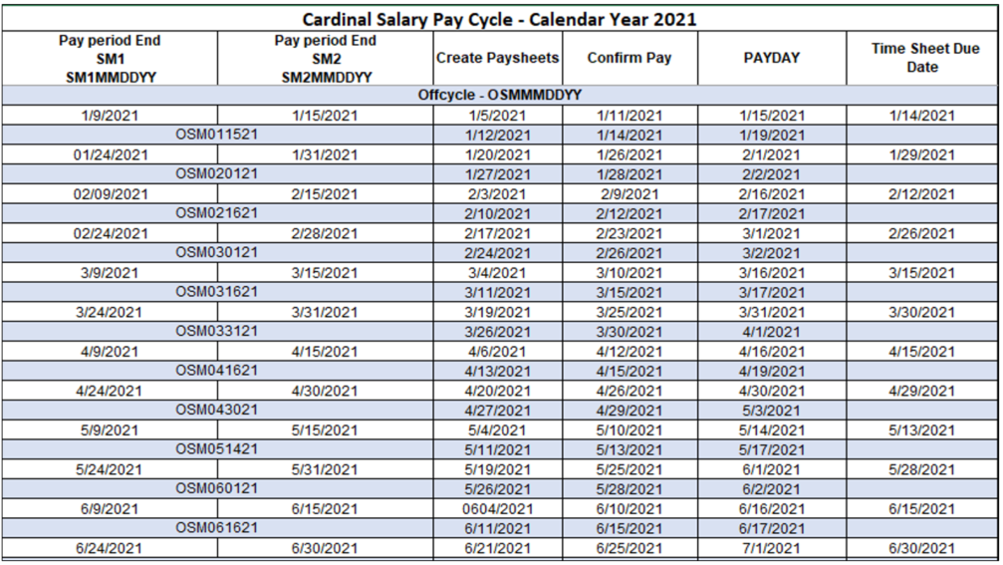

Time Administration Process
After employees/timekeepers enter and submit time/leave on the Timesheet, it is picked up for processing by the Time Administration process. This is an automated process that is run periodically throughout the day, which processes Reported Time (time/leave entered in the Timesheet grid).
The Time Administration process:

- Validates Reported Time against rules and generates time exceptions (low, medium or high severity) when it does not meet the rule criteria
- High severity time exceptions prevent the time from becoming payable, so those time exceptions must be reviewed, corrected, and resubmitted
- Generates Payable Time (from Reported Time with no time exceptions or low/medium time exceptions)
- Generates Payable Time for Exception Time Reporters based on their Work Schedule and Reported Time on the Timesheet
- Generates Holiday Payable Time (if applicable)
- Generates Shift Payable Time (if applicable)
- Routes the generated Payable Time for approval when approval is required

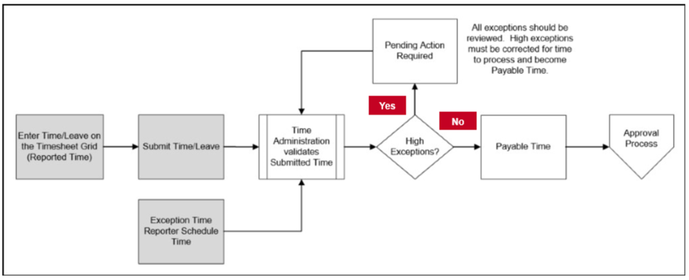

Time Exceptions
General Information:

After the Time Administration process completes, the following time exception scenarios can occur:

- No exceptions: Submitted time becomes Payable Time. No action is required prior to approval
- Low or medium severity exceptions: Submitted time becomes Payable Time with low or medium exceptions. The time exceptions should be reviewed, resolved, or allowed prior to approval
- High severity exceptions: Submitted time does not become Payable Time. Once corrected, Time Administration will clear the exception and the time becomes Payable Time. High severity exceptions must be reviewed and either resolved or allowed so that approval can occur and the employee can be paid correctly

While the TL Supervisor is responsible for ensuring that all time exceptions are resolved or allowed, before approving the time, the TL Administrator should review exceptions to make sure, at a minimum, no high exceptions exist before time is loaded/distributed by payroll and that supervisors are allowing exceptions when appropriate.

Time Exception Examples:
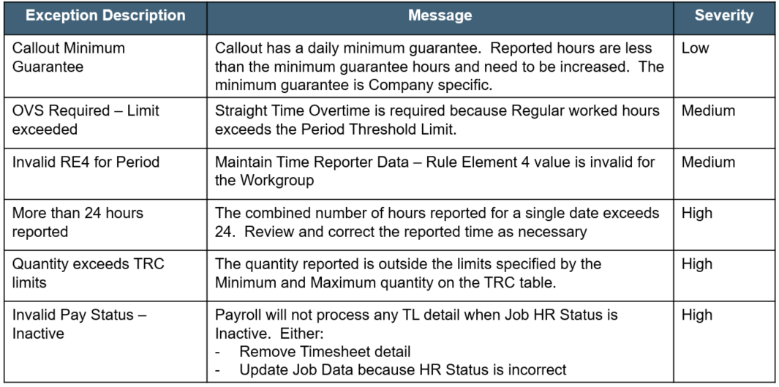
For a detailed list of all exceptions, see the job aid titled TA Exceptions. This job aid is located on the Cardinal website in Job Aids under Learning.

Absence Events

General Information:

Leave specifically refers to comp and overtime leave, which is entered on the Timesheet. All other types of leaves are referred to as absences and are entered on the Absence tab section of the Timesheet.

It is very important that the employee’s Work Schedule is accurate because absence durations, in many cases, are determined based on the Work Schedule.

Note: If the employee’s Work Schedule is not accurate, contact a Supervisor, TL Administrator, or TL Setup Administrator.

Absence events are created on the Timesheet by the employee based on the following guidelines:

- On the Timesheet associated with the date(s) of the absence
- If the absence is going to span across multiple pay/FMLA periods, multiple absence events need to
be created
- Cardinal allows users to define absence days as full or partial
- Salaried employees with a Variable Work Schedule must always use partial days
- Absence events must be forecasted prior to submission

Creating an Absence Event:
- Navigate to the employee’s Timesheet.
The Timesheet page displays.
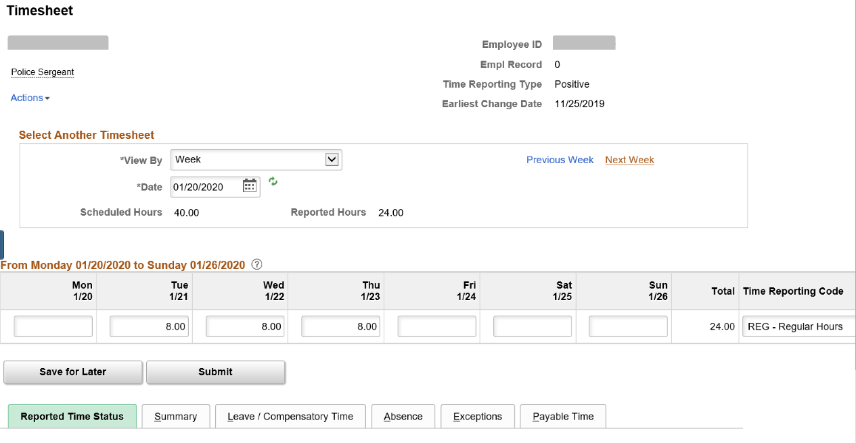

- Ensure that the correct Timesheet (dates) is displayed. Use the Date field, Previous Week link, or Next Week link within the Select Another Timesheet section as needed to navigate to the correct Timesheet.
- Click the Absence tab.
The Absence tab displays at the bottom of the page.
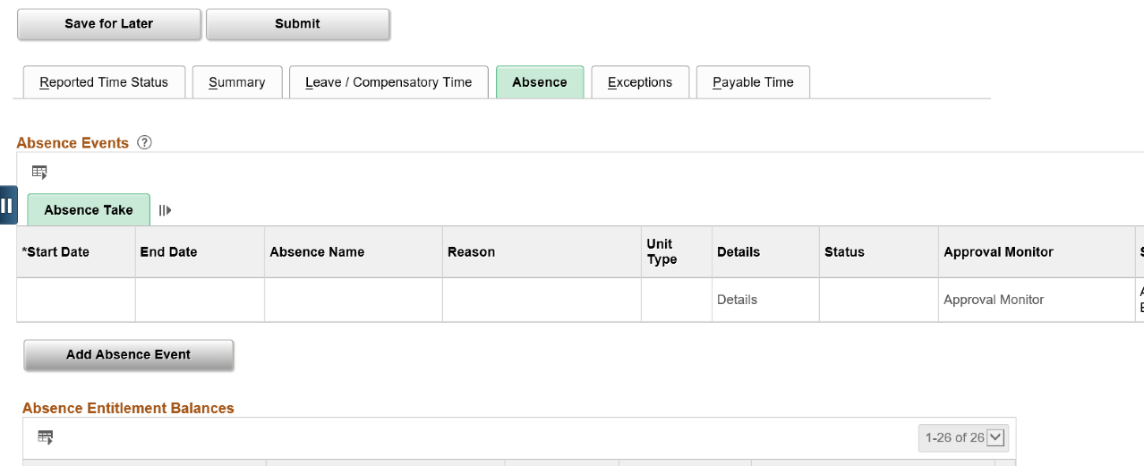
- Click the Add Absence Event button.

The Absence tab refreshes.
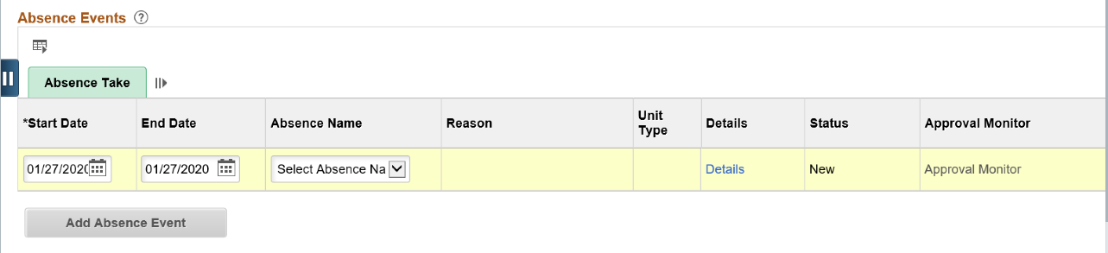

- The first row within the Absence Take grid populates with defaulted data. Notice that both the Start Date and the End Date fields default to the first day for the Timesheet. Update the start date as needed.
- Update the end date as needed.
- Select the applicable absence type using the Absence Name dropdown button.
The page refreshes.
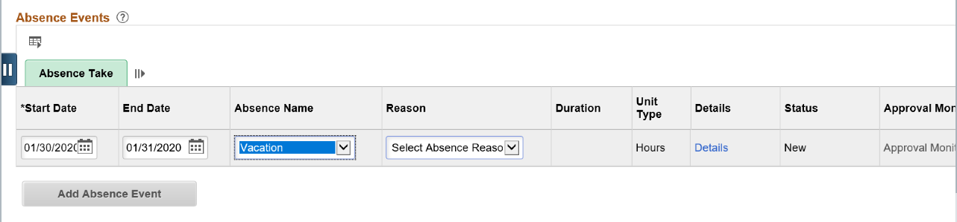
- Select the applicable absence reason using the Reason dropdown button.
- Click the Details link.

The Absence Detail page displays in a pop-up window.
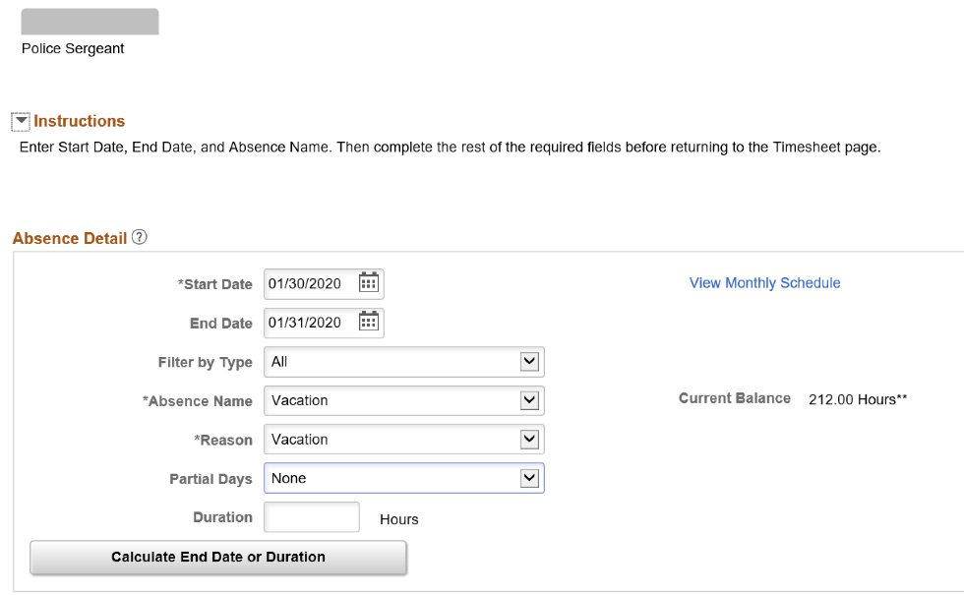
- The Start Date, End Date, Absence Name, and Reason fields default based on the information previously entered. Update as needed.
- The Partial Days field defaults to “None”. Select the applicable partial day option as needed using the dropdown button provided.
The page refreshes if a partial days option is selected. If no partial days option is selected, skip to Step 13.
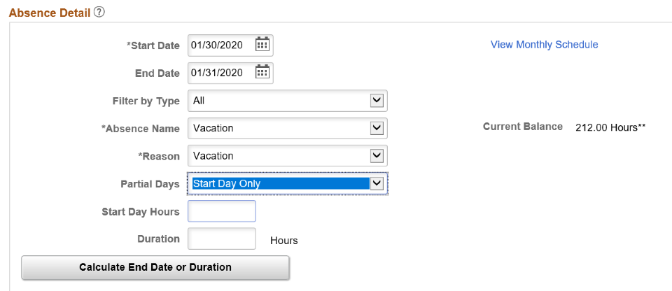

- Enter the applicable number of hours in the corresponding partial days hours field.
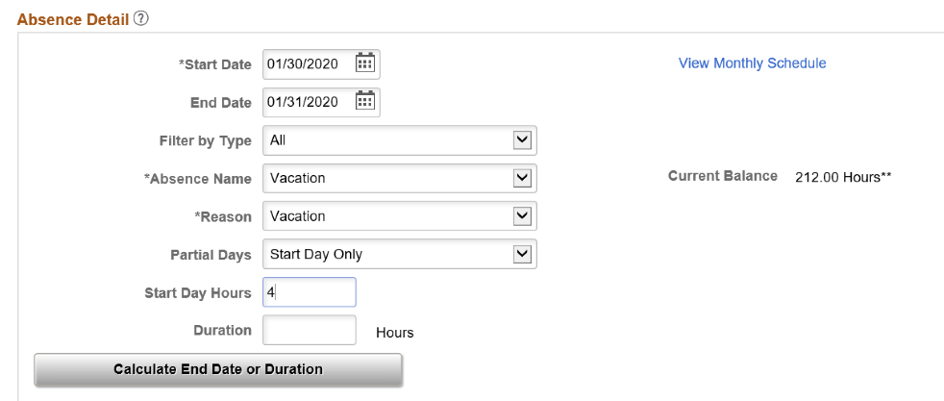
- Click the Calculate End Date or Duration button.
The page refreshes.
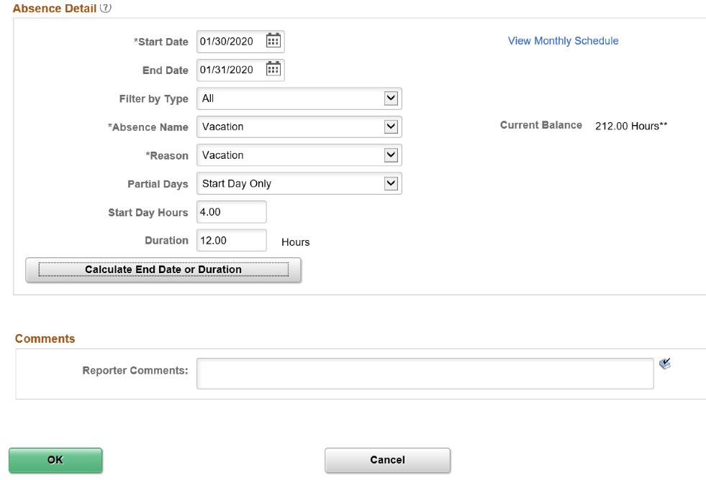

- The Duration field calculates and displays the applicable number of hours.
- Optionally enter comments in the Reporter Comments field.
- Click the OK button.
The Timesheet page redisplays.
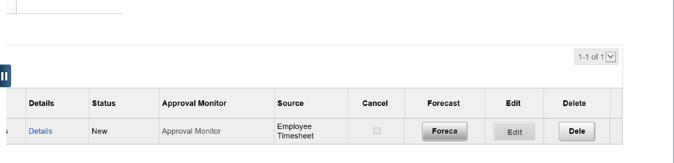
- Click the Forecast button.
The page refreshes.
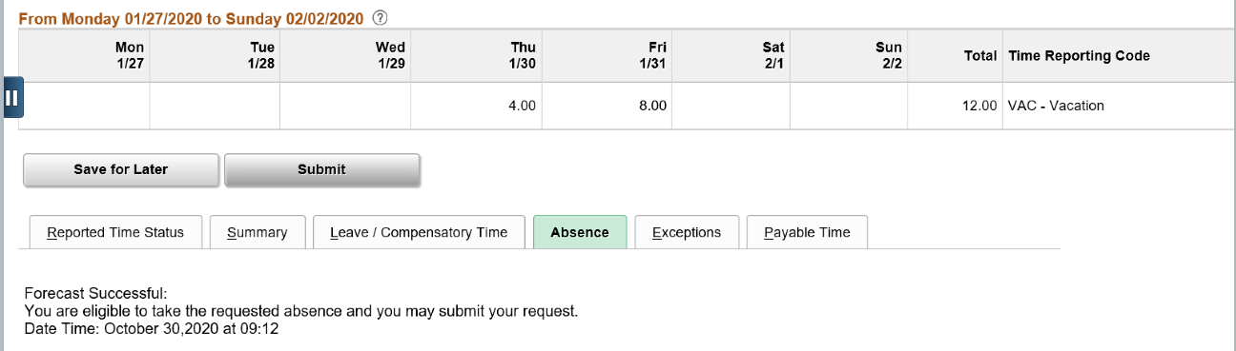
- Upon successful forecasting, a “Forecast Successful” message displays. Click the Submit button.
- Click the Submit button to submit the Timesheet for approval and processing.

The Submit Confirmation page displays.
- Click the OK button.

Reforecasting a Future Absence Event

Complete the following steps to reforecast (recheck) a future absence event:
- Navigate to the applicable Timesheet and click the Absence tab
- Verify that the absence event displays in the Absence Take grid
- Click the Forecast Results tab
- Review the Forecast Value field. If the forecast value is “Eligible”, there is still a sufficient balance for the absence event. If the forecast value is “Ineligible”, continue with Step 5
- Click the Forecast Details link
- Review the Absence Forecast Results page to identify the number of hours that will be paid and the number of hours that will be unpaid if the Timesheet is processed without any updates made to the absence event

Reforecasting Example
Today is March 28. In January, you had a Personal Leave balance of 24 hours. At that time, you entered a future absence event for a trip you are taking in April. You used the absence type of Personal Leave and the duration for the absence event is 24 hours. At the time of creation, the absence event forecasted successfully because you had a sufficient balance, and the absence event was subsequently approved.

In February, you had to take 2 days off unexpectedly. You created an absence event for the 2 days (16 hours) and used the Personal Leave absence type. The absence event was approved. You took the 2 days off, and the corresponding Timesheet was processed. This reduced your balance for Personal Leave to 8 hours.

You no longer have a sufficient balance for your planned absence event in April. If you do not take any action before the time of that absence event, the Timesheet will process with 8 hours of Personal Leave (your remaining available balance) and the remaining 16 hours will be processed as LNP (Pay Docking) which means you will not be paid for those 16 hours.

In this scenario, you need to re-check your April absence event which will allow you to identify this issue and avoid the pay docking by completing one of the following:

- Canceling the April absence event
- Updating the April absence event to change the duration or change the absence type to one where
you have a sufficient balance

Updating an Absence Event:

Complete the following to update an absence event:
- Navigate to the applicable Timesheet and click the Absence tab
- Click the Edit button for the applicable absence event within the Absence Take grid
- Make the required updates
- Forecast the absence event if required for the absence type
- Click the Submit button

Deleting/Canceling Absence Events:
Absence events that are no longer required can be deleted or canceled based on the following guidelines:
If the absence event has not been forecasted or submitted, simply click the Delete button within the Absence Take grid
If the absence event has already been forecasted, but has not yet been approved, the absence event can be cancelled by completing the following:
- Navigate to the applicable Timesheet and click the Absence tab
- Click the Edit button for the applicable absence event within the Absence Take grid
- Select the Cancel checkbox
- Click the Submit button

Note: If the absence event has already been approved, the employee cannot cancel it. In these cases, contact the Supervisor or an Absence Management Administrator to cancel the absence event.

Time and Absence Approval

Agency Configuration (Use of Cardinal)
The Agency’s configuration, or use of Cardinal, determines the categories of time that require approval. The table below shows the type of time that needs approval based on Agency configuration:
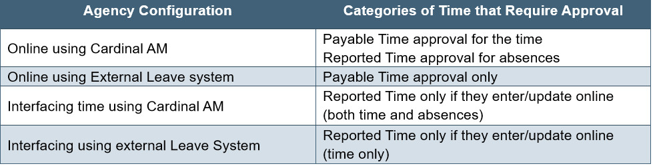
Note: For Agencies interfacing time, these transactions are considered approved in the agency system and only require approval in Cardinal if adjustments are made in Cardinal. As a general rule, in order to the keep information sync, interfacing Agencies should make adjustments to time in the Agency system and re-upload the information to Cardinal.

Approving Time and Absences:
Approvals in Cardinal for Reported or Payable time are done using the Approvals tile.
- Log into Cardinal HCM.
The Cardinal Homepage displays.
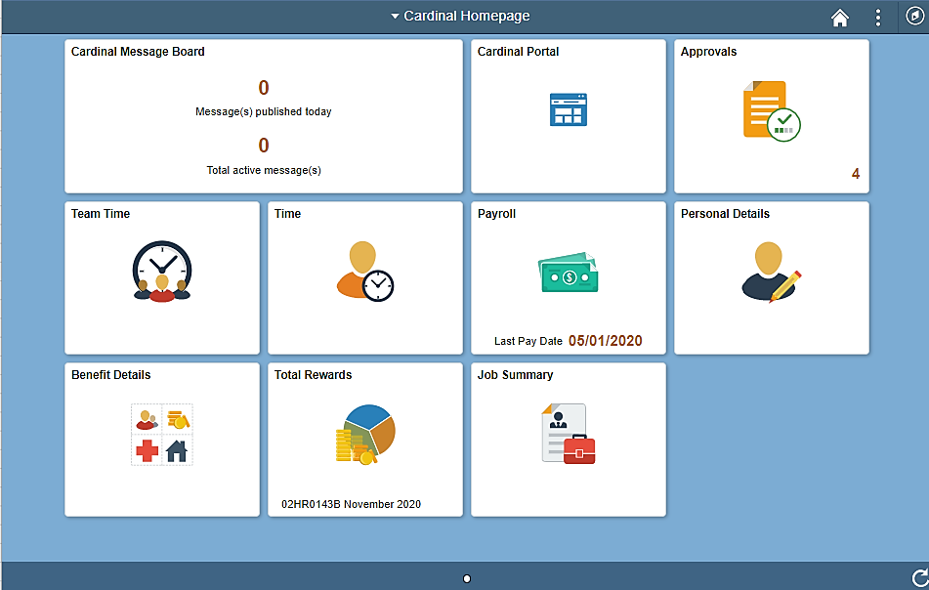
- Click the Approvals tile. The Approvals tile is on the Cardinal Homepage and indicates the number of items awaiting approval (both time and absences).
The Approvals page displays.
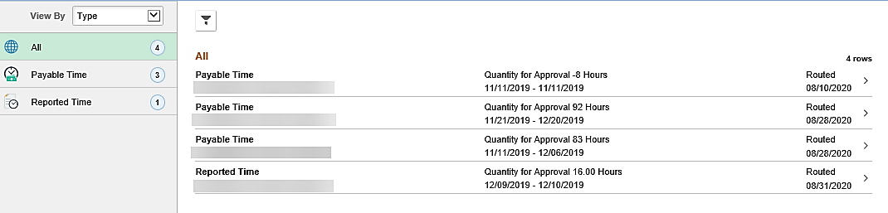
The left navigation menu displays the following:
- All – The total of all items (both reported and payable) that require approval
- Payable Time – The total number of payable time items that require approval
- Reported Time – The total number of reported time items that require approval

- Click the applicable line item to review the time or absence item.
The Payable Time or Reported Time page displays for the applicable item.
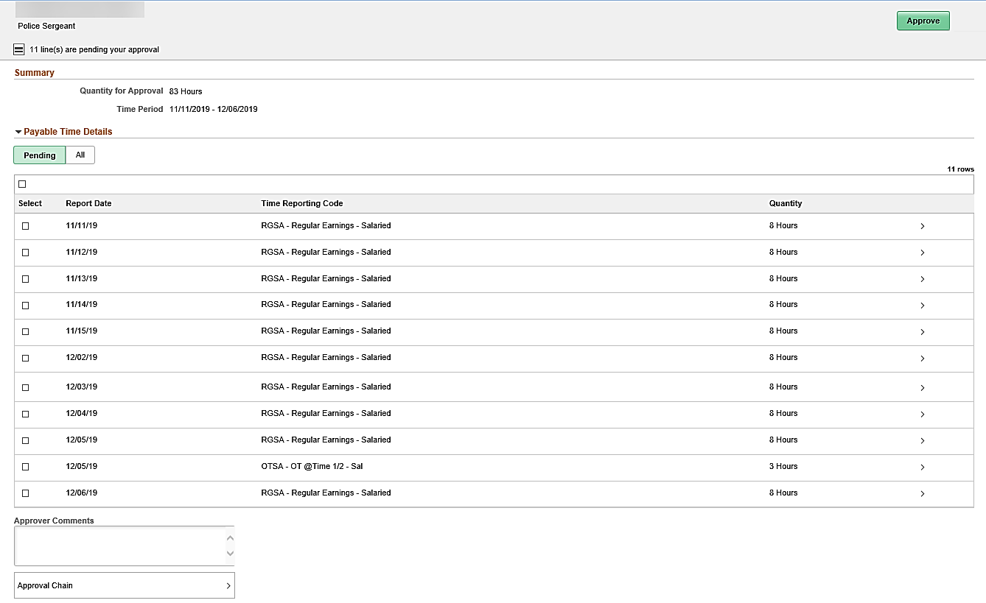
The Summary section at the top of the page includes:
  - Quantity for Approval – Total hours for approval
  - Time Period – The pay period of the time that requires approval

The Payable Time Details section includes two tabs:
  - Pending – Displays all time pending approval
  - All – Displays all time (both pending and time that has been approved for the applicable pay period)

Within the Payable Time Details section, the displayed time is broken out into lines that correspond with the lines on the Timesheet page (day and type). The overview information provided for review is:
  - Report Date – Date the time entered
  - Time Reporting Code – The TRC associated to the date and hours in the row
  - Quantity – Number of hours

While this section displays the key information needed to review and approve time, you can access additional details information and the employee’s Timesheet as needed by completing the following steps.
- Click the applicable line item.
The Approval Line Detail page displays for the applicable line item.
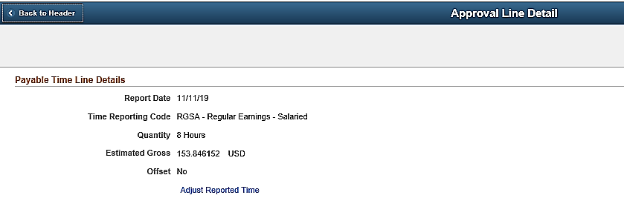
The Approval Line Detail page displays the Report Date, Time Reporting Code, and Quantity from the previous page as well as the following additional fields:
  - Estimated Gross: The estimated gross pay associated with the number of hours and TRC
  - Offset: This field indicates if the time is an offset. A negative number of hours for Quantity
indicates that there is an offset, meaning there was a change made to time previously approved
- No: No offset
- Yes: Offset and the Quantity number will be negative
Offset example:
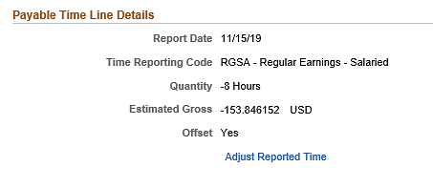
Note: All Offsets (negative hours) should be approved so that the employee’s hours are accurate.
The Adjust Reported Time link can be used to access the corresponding Timesheet if you need to:
  - Make any adjustments to the employee’s time
  - View additional time details such as the ChartField distribution

- Click the Adjust Reported Time link.
The Timesheet page displays.
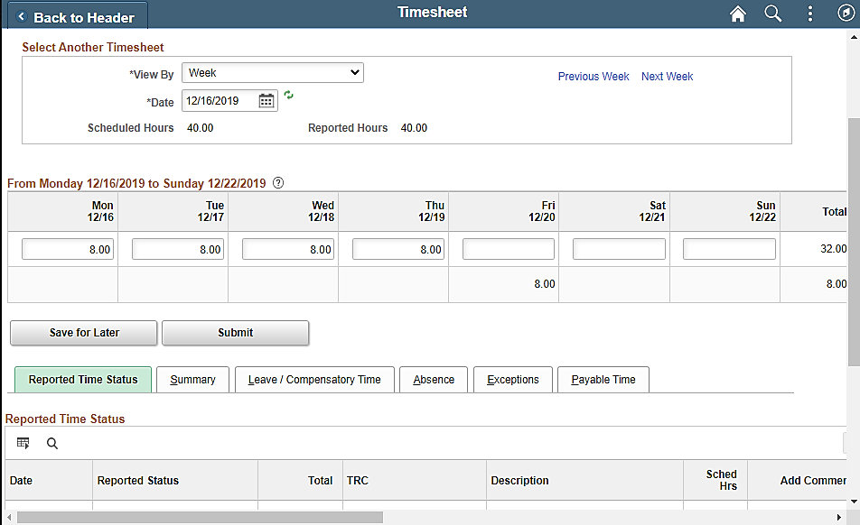
Note: The Timesheet defaults to the current week and not necessarily the week with the time pending approval. You may need to change the View By selections and refresh as needed.
- Review any specific data you need to see on the Timesheet or make any necessary adjustments.
Note: If you make an adjustment on the Timesheet grid, be sure to click the Submit button. Changes to time will not be available immediately for approval. The changes must be processed by Time Administration to route for approval. Check periodically to approve any changes made. Absences are available for immediate approval once they have been submitted.
- Click the Home icon to return to the Cardinal Homepage, after reviewing the information or making adjustments.

The Cardinal Homepage redisplays.
- Click the Approvals Tile.
The Approvals page redisplays.
- Click the applicable line item to approve.

The Payable Time or Reported Time page displays for the applicable item.
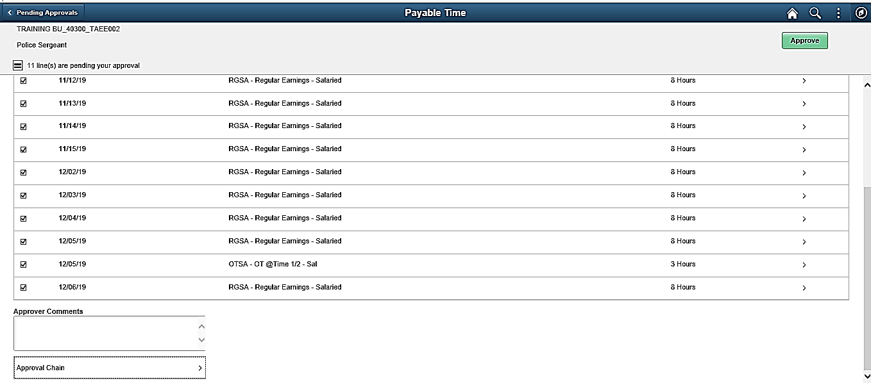
- Select the lines that are ready to be approved.
The bottom of the page contains the following fields:
  - The Approver Comments field allows you to enter comments, if applicable, regarding your approval

Note: These comments will not be available on any reports.

  - The Approval Chain link will open a pop-up window that displays with the approver’s name for each line on the page
- Click the Approve button.
The Approve page displays in a pop-up window.
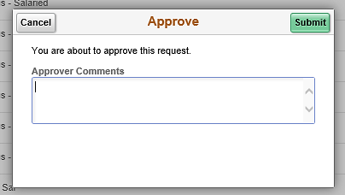
- Enter comments as needed in the Approver Comments field.
Note: These comments are not visible on any reports.
- Click the Submit button.

